Why Genius Hour

By Carly Baldwin, NBCT and Candi Williams, NBCT
Figure 1: Robbie and Nick demonstrating crochet
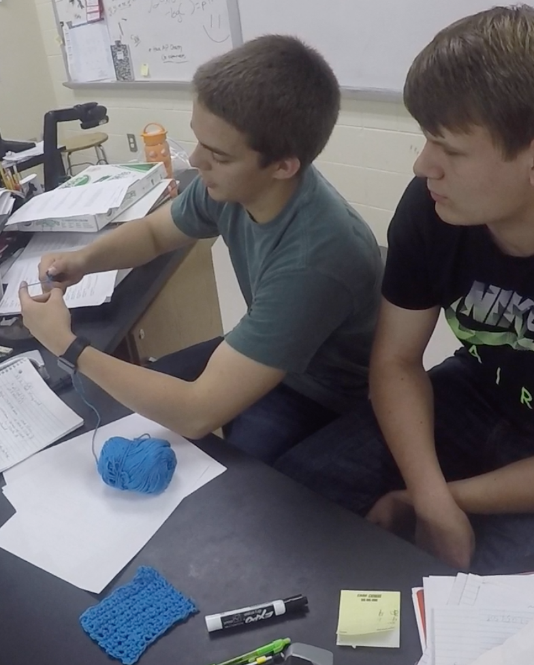
Starting something new in the classroom is scary. Instead of letting all the unknowns bog me down, I started with Why not? The questions the group asked were easy. What motivates you?, what drives you?, why do you do what you do? The answers were much harder. However, as I started to answer these questions, I realized that my students did not get the opportunity to answer these questions inside my chemistry class. I tried to solve the problem I saw; lack of student engagement, motivation and passion. The key word there is I. I tried to solve it. I didn’t ask for their opinion or voice. The answer to this problem was the beginning of Genius Hour.

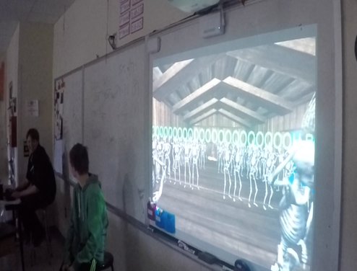
Was implementing Genius Hour easy? Ha! Not in the slightest. Was it worth it? Absolutely. A quiet nerdy boy that never spoke out in class developed his own video game with an easter egg room with skeletons dancing to cotton eye joe. A group of jocks that seemed like they could care less about chemistry, researched, built and tested their own potato cannon and learned quite a bit about combustion. Two picture perfect straight A students had a really hard time with their new found freedom. Watching them use their brains and creativity to design a breakout game for their peers was worth all of the chaos. Check out this video for some of our product presentations.
Figure 2: Video Game by Nick, Eric and Cody

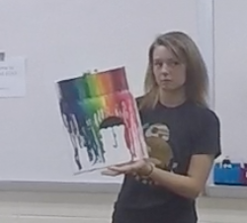
Let me back up. Genius Hour is a classroom strategy that allows students to explore their own passions and encourages creativity in the classroom. It provides students a choice in what they learn during a set period of time during school. I found that Genius Hour has rejuvenated my teaching practice from a sit and get learning culture to a student driven environment. Students gain choice and voice through their passion projects. This method of learning is often lacking in their education. On Fridays, my classroom transitions from a lab into a chaotic mess of passion products. Students were introduced to the idea of Genius Hour using this video, and then given the instructions to pick an idea that can be researched and demonstrated by a creative product.
Figure 3: Crayon Art by Chelsea
Figure 2: Crayon Art by Heather

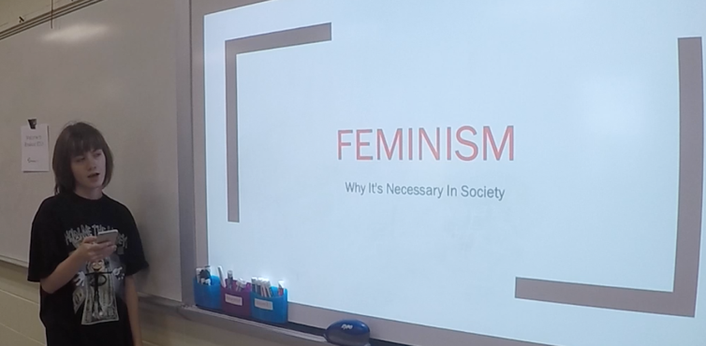
The best part of genius hour is the product can be shared globally! This is one way students are held accountable for their product. Products can be shared on the internet, a community gathering, or with a 3rd grade classroom. My students are creating better products and presentations because it will not stay "in house". Genius Hour became a way for me to truly let go, and let my students research, create and present something that they care about.
Figure 4: Alexis' presentation on Feminisim

This year I have been involved with a group called Classroom Teachers Enacting Positive Solutions (CTEPS); an amazing group of National Board Certified Educators. Because of the network created by CTEPS, I wasn’t alone in this journey. Candi Williams teaches 3rd grade and she saw similar attitudes in her classroom. She also wanted to implement Genius Hour to increase student engagement and motivation. We decided that as much as we wanted to collaborate, why couldn’t our students collaborate, too? Genius Hour connected a high school chemistry class and a 3rd grade class located hours away.

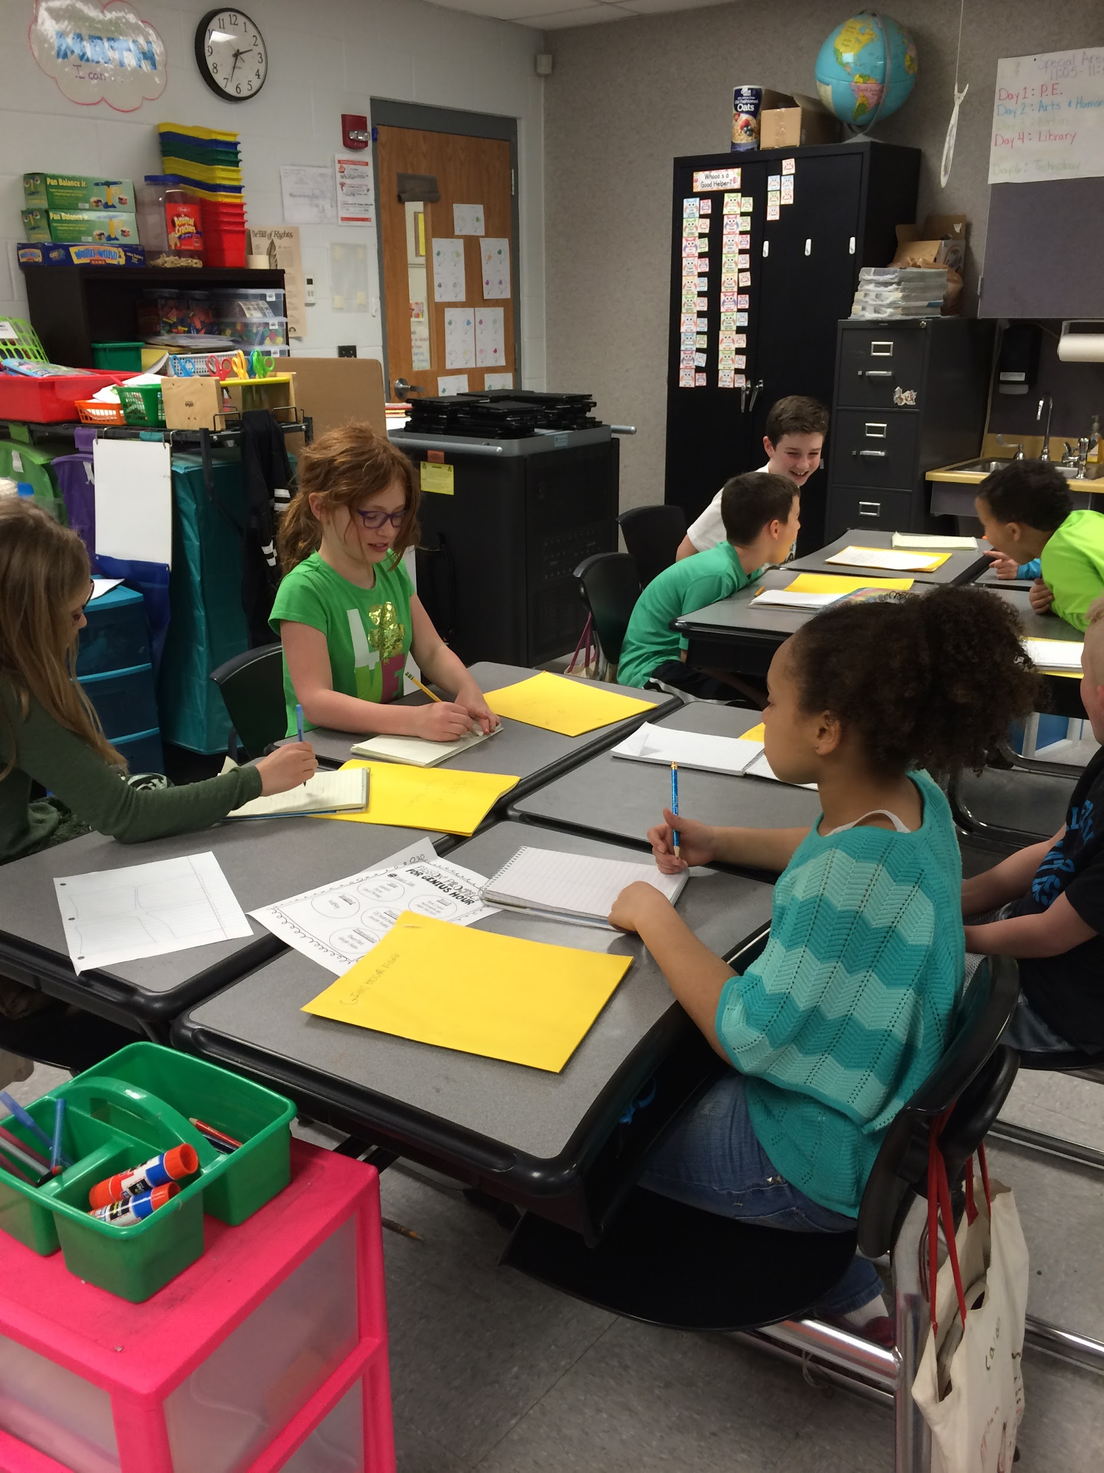
Candi’s class also worked on Genius Hour for an hour on Friday. She scaffolded the process for her 3rd graders to make it more manageable while the students get used to the process. They used the book "Hatchet" by Gary Paulsen to lead the idea discussion. Their question "If you were stranded in the wilderness like Brian, what would you hope you knew in order to survive? guided their Genius Hour projects. After brainstorming question, they needed to answer, the class was split up into small groups of 4-5 in 6 categories. That's when the research began. Each group was given graphic organizers to record their findings and began to think about how they would present their product to others. Her students did an amazing job on their products!
Figure 5: Water Group working on their product

She found that the rest of the school week was very productive and the attention her students gave her increased. They HAD to pay attention and get their work done in order to hold the Genius Hour. Their ownership of the school day increased with most students and their overall effort was improved. She described a couple of times that they gave up a coveted recess time in order to hold our Genius Hour meetings.
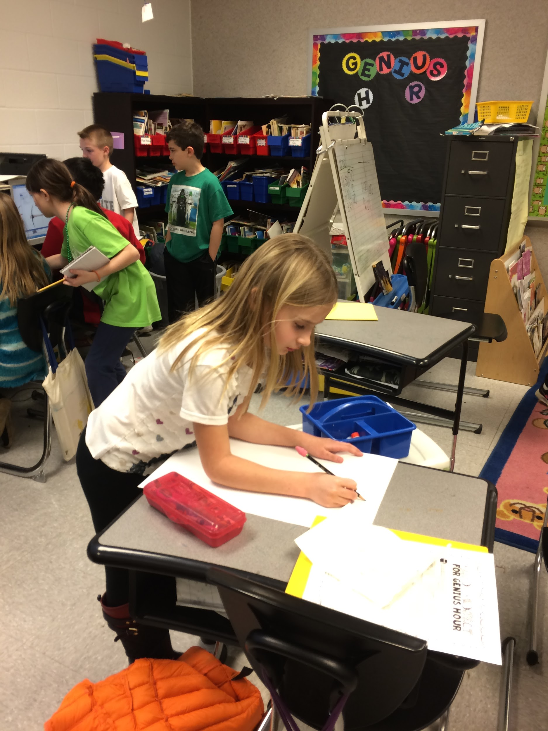
Figure 6: Hard at work making their product
The connections made between my High School students and her students were priceless. Candi heard conversations throughout the process like, “I wonder what our big buddies would think about this?” and “I wish I could ask my buddy because I think they would know.” Conner, a sophomore, said “are they presenting first? Because I’m not ready, and I want to make sure I know what I’m talking about before we get together”. Both classes put more effort into their product presentations because they knew the other class was going to be watching.

A few tips?
- Make sure you have a way for students to report their progress. Have them keep a blog, or fill out a google form along the way. Having regular conferences with students as they progressed was key for me.
- Have an authentic audience like a partner classroom. Candi’s 3rd graders were amazing motivation for my students. Even though they were 3rd graders, my sophomores wanted to be prepared to share their projects and not look silly.
- Make their presentations public and important to a real audience. The more you can involve the community and those outside of school (think industry partners and school board members) the better. My students were motivated because there was an actual point to it, and their project was not going to stay inside the classroom.
- Let go! Do not try and make their project fit what you are currently covering. Does that change the way you teach the other 4 days? Absolutely. That is part of Genius Hour’s charm.

Check out our Prezi showcasing more tips/tricks and videos from our students.

Carly Baldwin, NBCT, teaches at Boyd County High School and has taught for 7 years. Carly is passionate about developing teacher leadership demonstrated by her involvement in Hope Street Group, ECET2 and Classroom Teachers Enacting Positive Solutions (CTEPS). She is married and loves to hike with her husband, Brian, and their two dogs. Carly earned a Bachelors degree in Biology from Murray State University and a Masters Degree in Education from the University of Tennessee at Martin.

Candi Williams, NBCT

