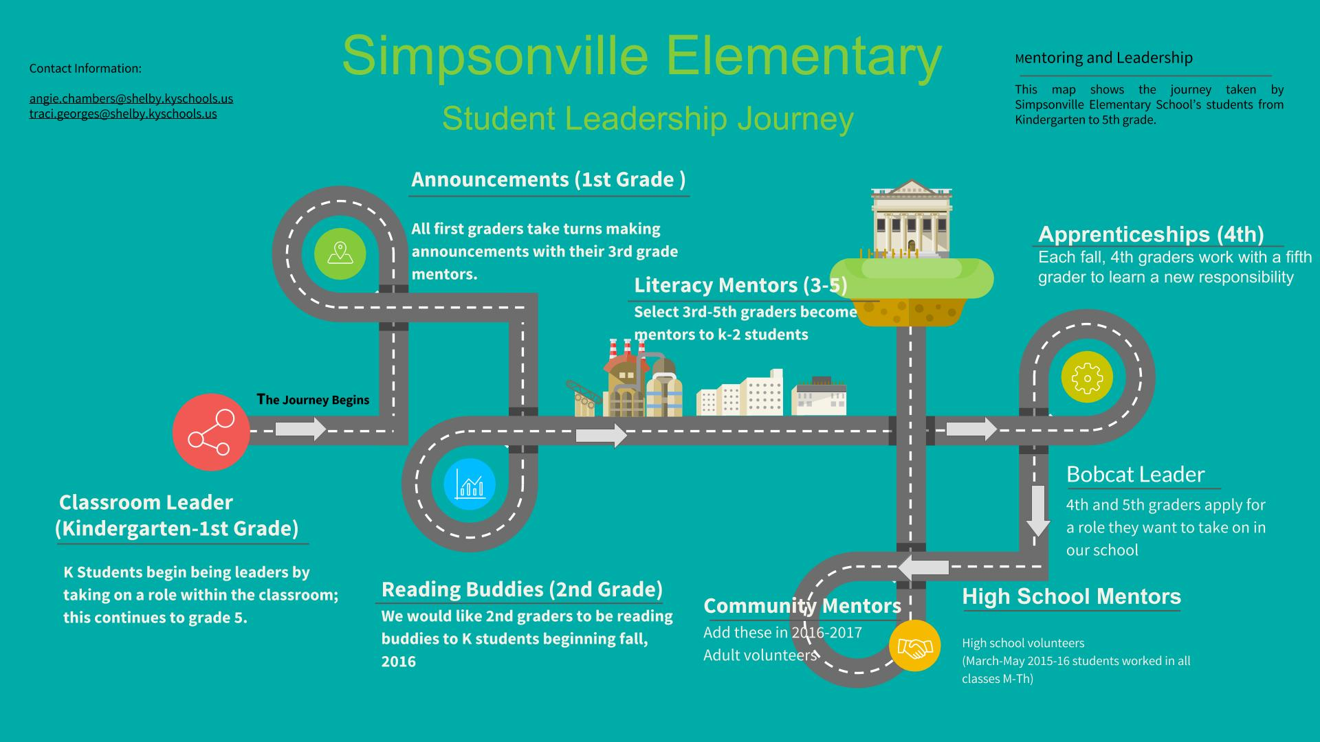

EMpowering Students through Leadership and mentoring
Angie Chambers, NBCT
"Leadership is communicating people's worth and potential so clearly that they are inspired to see it in themselves." ---Stephen R. Covey
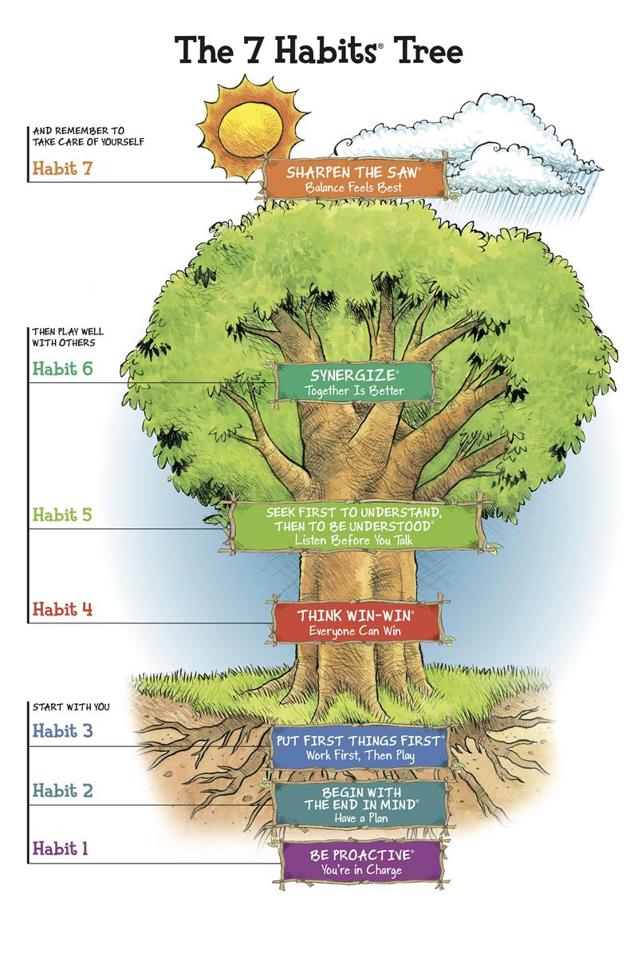

our Roots

WHat is the leader in me?
Simpsonville Elementary School is in its second year as a Leader in Me School. The Leader in Me is an approach to developing a culture of leadership in our schools and is based on The 7 Habits of Highly Effective People by Stephen Covey. The Leader in Me model emphasizes skills that parents, teachers and business leaders want and that students need to be successful in an ever changing society. Our journey began by introducing The 7 Habits to our all students, Kindergarten through 5th Grade. The habits can be taught through interactive stories from The 7 Habits of Happy Kids, with lesson plan and activities. Each habit teaches a quality of great leaders. For example, Habit 1 - Be Proactive, teaches students that they are in charge of their actions, attitudes, and moods. The language of the habits is consistent throughout the building and is taught in and out of each classroom. You will see the posters of the story characters and The 7 Habits Tree Diagram in every classroom and around the building of Simpsonville Elementary School.

Our mentoring Project

How Simpsonville teachers are Taking student leadership to Another Level

“I feel so honored to have been chosen to be a first grade mentor.”

-second grade student

In September of this school year I was invited by my assistant principal to attend a conference on reducing behavior referrals and suspensions. The message that I left with that day was, students must feel a personal connection to their school. Students need to feel valued, important, and have ownership in their daily routine. My project idea became clear that day. I wanted to empower students by having them build relationships within our building that made them feel important. In accordance with The Leader in Me, I started with my current class by making sure that every student had a classroom responsibility. Next, I invited some second, third, and fourth graders to become student mentors for my class. I chose two second grade student to be first grade mentors. These students came to my classroom every morning, read with students and assisted students with morning work. “I feel so honored to have been chosen to be a first grade mentor,” was the response that one of these students said to her teacher.
I partnered with a teacher whose third graders became mentors to my students by teaching them how to lead the morning announcements. Our two classes formed close relationships this year. The first graders looked forward to spending time with their mentors who supported them by writing stories, reading books, or just being an audience. When I asked my class how they liked working with a student mentor they all had positive responses. “I like my mentor because he helps me be a better writer,” “My mentor is nice and always help me,” and “My mentor listens to me if I have a problem,” are some of the responses I heard. I noticed that even the quietest students began to open up and build trust with their older mentor. The first graders looked up to their mentors and the third graders exuded a sense of importance as they were always greeted with hugs, high fives or handmade cards. Three of the third grade mentors became regulars in my classroom. They stopped by weekly to sharpen pencils, organize leveled books, and help students with classwork. These girls were identified by their teacher as girls who would benefit from extra leadership roles.

“I like my mentor because he helps me be a better writer.”

–first grade student

My latest mentoring project was with a fourth grader who was a previous student of mine. I know her history and I know that her first few years of life were not the loving and nurturing times that she needed. She has developmental delays and has struggled in school. I felt that more than anything she needed to feel valued. I passed her in the hallway many times this year and wondered what she was going through, what she was thinking, why she looked so sad, as I looked into her lost and empty eyes. After consulting with her teacher, she now came to my classroom at the end of the day to be a math mentor to a few of my students. She didn’t always contribute much and some days she walked around with a blank stare but she always remembered to tell her teacher that she needed to do her job. When I pass her in the hallway now she stops and talks to me about what’s going on in her life.
Research supports numerous benefits of student mentoring.
- Provides students with a personal connection
- Helps students feel like someone “has their back”
- Improves self-esteem
- Increases student morale and motivation
- Improves academic confidence and performance
- Increases attendance and class participation
- Improves relations with peer, teachers, staff and families
- Reduces classroom disruptions, fighting, and other negative behavior
- Improves homework completion
- Help students perceive school, teachers, and work in a more positively

[Cite your source here.]

Our impact

The Evidence and Results

I collaborated with our Art teacher, Traci Georges, who has been instrumental in creating many student leadership roles this school year.
Last year she implemented a weekly news program focused on the 7 Habits. This year she opened a coffee shop, “The Bean” to provide further leadership opportunities. We joined forces and invited some of my first graders to read in the coffee shop in the mornings with a coffee shop student mentor. They would read together and deliver coffee to staff members. We wanted to know if the plan was having an impact on students academically and socially.
Fourth and fifth grade students were surveyed in the fall of 2015 during their Art class taught by Traci. The results certainly support the leadership role initiative as well as the social nature of learning. Students reported that having a leadership role was either very helpful or helpful. Very few students marked “not helpful” on their survey. The conclusion of this research was that student leadership roles made a significant impact on Simpsonville students.
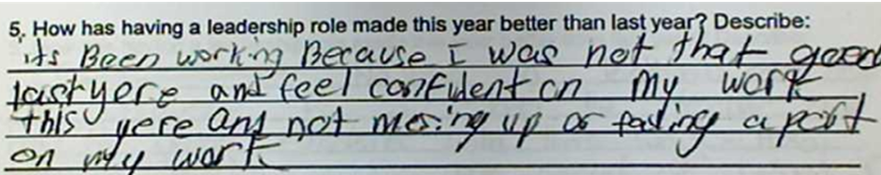

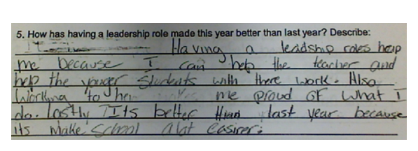

our support

How Cteps supported our vision of student leadership and mentoring

Traci Georges and I were chosen to participate in CTEPS (Classroom Teachers Enacting Positive Solutions). CTEPS is a cohort of National Board Certified teacher from across the state. Without CTEPS the work that we have done this year to grow student mentors and leaders would not have happened. This group supports and empowers one another through projects within our schools that will impact students in a positive way. We are there for each other through a series of face to face and virtual meetings. Since Traci and I are supporters of The Leader in Me, it seemed natural that we would both choose a project that was based around leadership. In fact at our first meeting without knowing we chose the exact same topic.
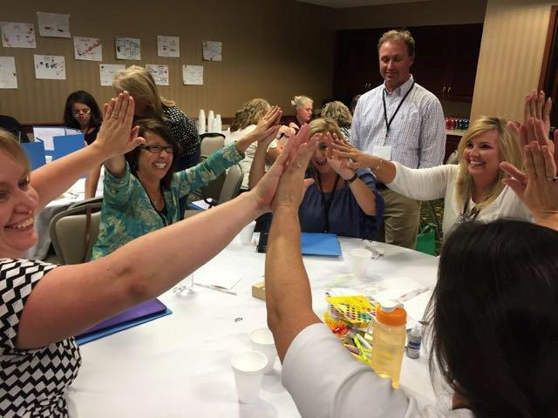
Our involvement in CTEPS challenged us to identify, reflect and launch our mentoring and leadership project. We attribute the success of our project to the support of our CTEPS cohort and The Leader in Me professional development. We were allowed time to reflect and receive feedback during our CTEPS workshops. Developing a culture of leadership and mentoring at Simpsonville Elementary School is about helping children be leaders of their own lives. With our guidance they will be able to identify their own unique strengths and talents. Educators have the ability to empower all students to make a positive difference in the world. I am fortunate to work in a school district that allows me opportunities to pursue professional development that benefits my students and me directly.

To learn more about our leadership and mentoring program, contact Angie Chambers at angie.chambers@shelby.kyschools.us and Traci Georges at traci.georges@shelby.kyschools.us

Video Link:
To see what Simpsonville students have to say about leadership go to www.wevideo.com/view/668871491

